Ref: 1823 MB/EM

14th February 2019

Dear Parents,

Optional Revision Guides

In our efforts to ensure that all students maximise their potential within the GCSE examinations we are writing to you detailing a collated list of recommended revision resources and key texts to support students with the development of their subject knowledge. All of the texts recommended can be purchased from the Academy using the cashless system.

This list has been compiled in response to requests from parents and students. It is our view that these are not compulsory purchases, as we cover all relevant material in lessons. They are not essential requirements for completion of the courses. For those who feel these would be beneficial, then we are happy to signpost you to what we would recommend, if this is something you wish to do. There is no expectation from us that students must purchase the revision texts listed.

The window for ordering through the cashless system will be open from Friday 15th February to Friday 8th March. The purchased resources will then be available for collection within school from Tuesday 12th March.

The table of resources will be sent out via Schoolcomms on Friday 15th February and will contain the ISBN of the texts, which can be used to search and order the resources both online and in store. This gives you the freedom of choice to order through us or to purchase yourself elsewhere. Please note, you may only cancel an order and receive a refund before the window closes on Friday 8th March.

If you have any further questions or queries, please do not hesitate to contact us. We hope you find the guidance useful.
Yours faithfully
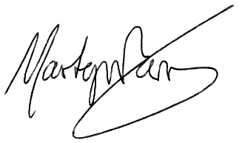

Mr M Berry
Head of School

